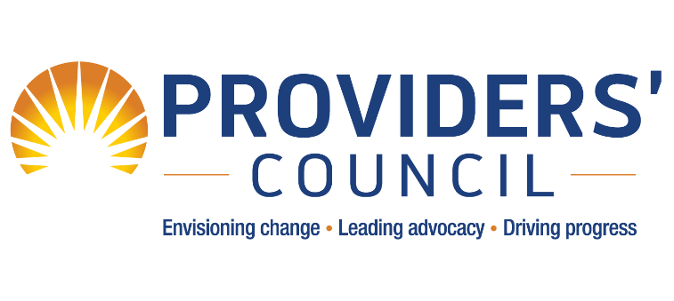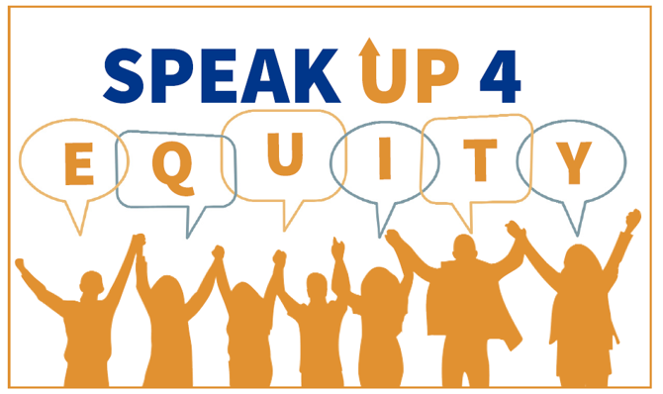
Group Registration Form for the Virtual 45th Annual Convention & Expo from October 27 – 30, 2020
Agency: | Contact: |  | Title:
[TYPE HERE] | [TYPE HERE] |  | [TYPE HERE]
Address: |  | City / State / Zip:
[TYPE HERE] |  | [TYPE HERE]
Phone: |  | E-Mail:
[TYPE HERE] |  | [TYPE HERE]

FEES:
Early Bird Registration - ends 9/18/2020 Regular Registration Pricing – begins 9/19/2020
Members: $60 Members: $90
Nonmembers: $110 Nonmembers: $160

PLEASE INDICATE HOW MANY PEOPLE YOU ARE REGISTERING:
□ 1 – 9 registrants: # of Registrants _____

□ 10 – 19 registrants, there is a 10% discount: # of Registrants _____
□ 20 or more registrants, there is a 20% discount: # of Registrants _____

TOTAL AMOUNT DUE: _______________

PAYMENT METHOD:
□ Check (payable to the Providers’ Council, 100 Crossing Blvd, Suite 100, Framingham, MA 01702)
□ VISA
□ Mastercard

Please contact tjordan@providers.org to pay securely via credit card. DO NOT send credit card information via email.

Secure your chance to win EARLY BIRD RAFFLE PRIZES by submitting your registration by the September 18 deadline!

LAST DAY TO REGISTER IS OCTOBER 20
Mail Registration Form and Payment: Providers’ Council, 100 Crossing Blvd, Suite 100, Framingham, MA 01702
Questions? Contact pdaily@providers.org.
*Your email address is your ticket to our virtual event* It MUST BE UNIQUE to the individual being registered.
Name | Job Title | Email Address* | CEU Type  (Social Work, LMHC, or LADC) | CEU License Number | Special Accommodations?  (i.e. sign language interpreter)

