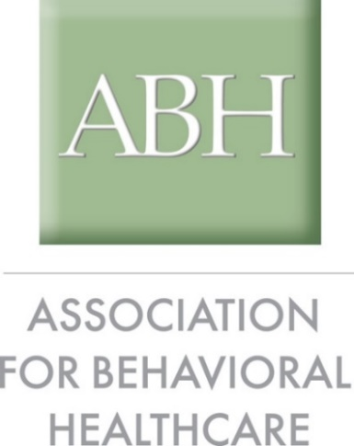
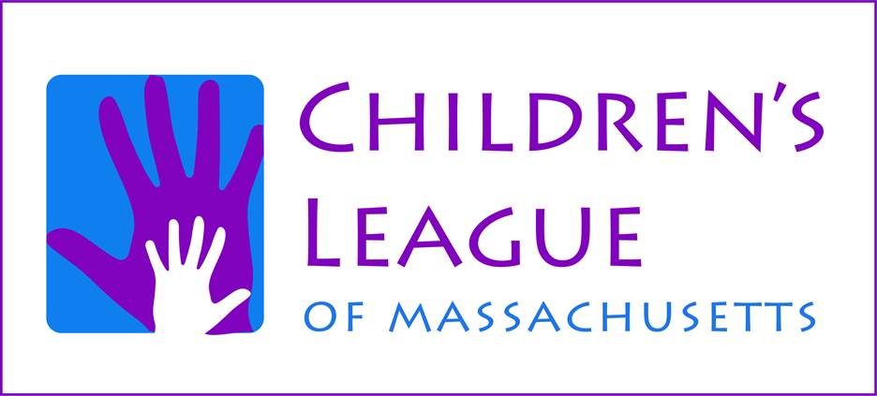
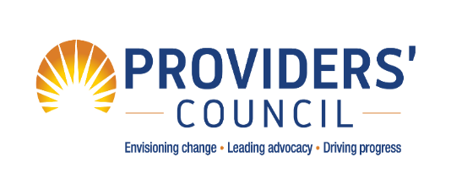

May 15, 2020

Executive Office of Health & Human Services
c/o D. Briggs
100 Hancock Street, 6th Floor
Quincy, MA 02171

Re: 101 CMR 413.00: Rates for Youth Intermediate-Term Stabilization Services

To Whom It May Concern:

The Association for Behavioral Healthcare (ABH), the Children’s League of Massachusetts (CLM) and the Providers’ Council represent the majority of providers of children’s services in residential and congregate care, as well as in community-based settings, within the Commonwealth of Massachusetts. On behalf of our many members, we appreciate the opportunity to submit testimony relative to the proposed rates Youth Intermediate-Term Stabilization Services.

We greatly value the Executive Office of Health & Human Services’ (EOHHS’s) ongoing commitment to biennially review rates paid by governmental units to providers of social service programs. We sincerely appreciate the efforts by EOHHS to address workforce challenges, specifically the inclusion of an unprecedented $160 million reserve to support human and social services and the transition away from the Uniform Financial Reports (UFRs) toward external salary and cost benchmarks.

In committing to shift away from the UFR to external salary benchmarks, EOHHS indicated in FY21 budget materials that the intent was to support “providers’ ability to hire/retain quality direct care and clinical staff by using an updated rate methodology benchmarking wages to the Bureau of Labor Statistics median salary.” While we support EOHHS’ movement toward external benchmarks, we respectfully request that EOHHS re-engage with The Collaborative in a process to review and refine the occupational codes selected, the use of the median salary versus a higher percentile benchmark and the development of a standardized tax and fringe rate that supports human service employee access benefits that they deserve.

Many of the benchmarks proposed by EOHHS are at or below salaries already paid by our members to program staff. As members of The Collaborative, we recommend that the Commonwealth adopts the BLS-MA 75th percentile salaries for benchmarked positions. Given that salaries are benchmarked for 2021 services, this salary level appears more consistent with the competitive salaries required to recruit and maintain human services staff in the current economic climate.

In addition to the fundamental challenge of benchmarks that are set too low, we make the following comments and recommendations:

- We, as members of The Collaborative, recommend an Administrative Allocation of at least 12.5% for Youth Intermediate-term Stabilization Services. The proposed 12% is inadequate, in light of the ever-increasing complex burdens associated with contract, billing, and compliance management;
- We recommend a Cost Adjustment Factor (CAF) of 3.24%, as the proposed CAF of 1.78% is set too low;
- Our members believe that the proposed tax and fringe rate is set too low. We respectfully request reconvening with EOHHS on the refinement of a standardized tax and fringe rate.
- Operating expenses do not correspond with providers’ true expenditures for occupancy, travel, personal protective equipment, other expenses including staff training, and persistent unrecognized costs;
- The lack of a consistent utilization factor across programs is problematic. We recommend that an 85% utilization factor be adopted across program types; and
- The proposed rates do not account for indirect costs associated with the implementation of the Paid Family and Medical Leave Act (PFMLA).

- Salary Benchmarks

We appreciate EOHHS’s efforts to move away from antiquated UFR data and to use external BLS data to determine appropriate salary benchmarks. We are extremely disappointed, however, that benchmarked salaries have not leveled the playing field between program models and are creating further imbalance among providers.

It is critical that the Commonwealth factor in the requirements of the Family First Prevention Services Act (Family First) and the Family First Transition Act (Transition Act) into the new rates for DCF services. Specifically, Massachusetts will need to incorporate Family First’s Qualified Residential Treatment Programs (QRTPs) and evidence-based in-home services into its rate development for the DCF procurement. For example, QRTPs must have registered or licensed nursing and other clinical staff who provide care, are on-site consistent with the trauma-informed treatment model and are available 24 hours per day/7 days per week. As addressed below, by adopting the BLS-MA 75th percentile benchmark, the Commonwealth will ensure that providers are able to employ and retain critical clinical staff who provide care consistent with the federal standards.

In 2019, ABH engaged Arthur J. Gallagher & Co. to conduct a Compensation and Benefits Survey of its member provider organizations, many of whom are also CLM and Providers’ Council members. Several of the proposed Chapter 257 salaries reflect salaries at or below the current salary level paid by our member organizations. For instance:

- LICSW – This position has a proposed annualized salary of $60,923. The 2019 survey revealed that ABH members paid $58,781 annually for LICSWs. This position also accounts for one of the more senior clinical roles in youth residential programs, determining the treatment plan for children at risk and/or with behavioral health needs. The ABH survey reflected that hospitals pay LICSWs an annualized salary of $75,005. We recommend that the Commonwealth adopt the BLS-MA 75th percentile for the LICSW position at $75,984.71.

- LCSW/Case Manager – This position has a proposed annualized salary of $52,666. The 2019 survey revealed that ABH members paid $52,437 annually for LCSWs and that hospitals pay an annualized salary of $66,685 for the same position. We recommend that this position be funded at the BLS-MA 75th percentile for the LCSW position at $66,899.73.

- LPN – This position has a proposed annualized salary of $57,450. ABH’s survey indicates that its members are currently paying $55,515 for this position and the same survey reflects that an LPN in a hospital setting is compensated at $64,584. We recommend that this position be funded at the BLS-MA 75th percentile with an annual salary of $63,253.

- Direct Care – This position has a proposed annualized salary of $32,198. ABH’s survey revealed that the average salary paid for a DCI staff is $33,010 and DCII staff is $37,482, both of which exceed the proposed benchmark. We strongly recommend that the Direct Care position be funded at the BLS-MA 75th percentile salary benchmark for DC staff at an annualized salary of $39,190.67.

- Relief – Again, we strongly recommend that Relief positions be funded at a level to reflect the Direct Care level. A rate equal to that of the BLS-MA 75th percentile for Direct Care staff, i.e., $18.84 per hour enables providers to reduce turnovers and staff vacancies that negatively impact children receiving services from DCF and DMH.

- Administrative Allocation

Together we reiterate previously submitted testimony that the method used to calculate the proposed rates apparently weights the average of Adjusted Management and General (M&G) expenses across providers, which results in different Administration cost bases across provider organizations.

For instance, the Administration costs for Intensive Residential Treatment Programs (IRTPs) within the Youth Intermediate-term Stabilization Services are proposed at 9.47%, while Short Term Assessment and Rapid Reintegration (STARR) programs, Group Homes, and the Continuum Program are proposed at 11.85%. Meanwhile, both the Co-occurring Enhanced and Adult Community Clinical Services rates have an administrative allocation of 12%. We restate our members’ preference and that of The Collaborative that there be an Administration cost base of at least 12.5% for Youth Intermediate-term Stabilization Services. Given the ever-increasing administrative responsibilities placed on provider organizations and costs associated therewith, a 12.5% factor to account for administration is reasonable.

- Cost Adjustment Factor (CAF)

Even with the workforce add-on, the proposed CAF of 1.78% is inadequate for a prospective rate adjustment and fails to account for increases to non-workforce expenses such as fuel, rent, maintenance, as well as regular cost of living increases and the rising cost of health insurance.

Furthermore, the effects of the COVID-19 pandemic will have long lasting fiscal effects on the Commonwealth, in particular on children’s service providers, and the proposed CAF is not equitable in light of financial forecasts. We strongly encourage EOHHS to adopt the IHS Economics’ pessimistic scenario and establish a more realistic cost adjustment factor of 3.24% that captures expected increases in costs.

- Tax and Fringe

Although the proposed tax and fringe rate of 22.31% has been applied universally to new Chapter 257 rates, it still does not provide a sufficiently priced tax and fringe benefit for employers. Fringe benefits for staff in provider organizations have been suppressed because reimbursement rates were inadequate to offer strong benefit packages. Providers have been compelled to reduce or eliminate defined employee benefits. Our members pay and/or contribute to such costs as long-term disability, short-term disability, group life insurance, employee assistance programs, tuition reimbursement, and health insurance. Very few organizations can offer or match employee retirement benefits due to narrow operating margins. As health insurance costs continue to rise, providers have had to pass along more costs to staff in efforts to limit, or at the very least contain, employer paid premiums because of inadequate revenue. Once the nation has had a moment to pause and recover from the COVID-19 pandemic, it is expected that insurers will increase costs in the aftermath.

We respectfully request reconvening with EOHHS to develop a standardized tax and fringe rate that supports human service employee access to health insurance and retirement benefits that they deserve.

- Operating Expenses
Children’s services providers support DCF and DMH clients in several treatment settings, including 24/7/365 care. These services are often clinical in nature. The Operating Expenses as proposed do not consider providers’ actual costs to meet their contractual obligations to address the needs of the Commonwealth’s most vulnerable citizens.

- Occupancy –The largest proposed increase in Occupancy costs was in the Teen Parent program, at an increase of only $0.70 per day. Programs lagging behind this were Clinically Intensive Residential Treatment (CIRT) and STARR with an increase of $0.60 per day, Transitional Age Youth programs at an $0.53 increase, Group Homes ranging from $0.53 - $0.55 daily increases, and Continuum – Residential with an increase in Occupancy costs of just $0.34. These proposed increases to Occupancy Costs are offensive to children and families who deserve a residential or congregate care setting that is warm, inviting and as home-like as possible. Providers and staff also require a safe physical environment to provide the best possible services for children. From the onset of the Chapter 257 rate process in 2008, regional differences in occupancy costs have not been addressed adequately. Providers in higher real estate markets incur significantly greater costs for rent, maintenance, contracted labor (i.e., HVAC, plumbing, electrical, snow removal, cleaning, and landscaping), property liability insurance (based on property value), etc., As a result, the gap has widened over the past twelve years as the costs of these occupancy components have increased much faster than inflation. Programs are also reconfiguring and redesigning their space to meet social distancing recommendations, which comes at additional cost. Lastly, the damage and cost of upkeep that occurs in Group Homes and STARR programs is not accounted for in any of these costs. The overall Occupancy costs as proposed need to be adjusted upwards by at least 50% to account for these factors.

- Travel/Additional Travel – Throughout the program models for Youth Intermediate-term Stabilization Services, travel expenses have been ignored within the FY21 rates. For those program models that include a daily travel rate or additional travel, there is no increase whatsoever. This head-in-the-sand approach as to how children’s services programs operate, such as transporting youth to medical appointments, school meetings, community outings, etc. cannot continue. The existing daily travel cost ranging between $0.62 per day for Continuum – Community Wrap, $0.71 - $0.75 for those Group Homes (where it is even factored in), and $2.28 for STARR is unsustainable. If one utilizes the federal mileage allowance of $0.575, youth in these programs are only traveling a total of 7.5 miles (Continuum) to 27.76 miles (STARR) per week. This cost also does not account for vehicle expenses such as fuel, lease, maintenance, insurance, vehicle depreciation, etc. Meanwhile, staff often transport children in their own vehicles and are required to obtain more comprehensive business insurance coverage which is then reimbursed by providers. We recommend that there be consideration of an individual staff transportation cost and that the travel/additional travel expenses be increased to align with that of the Adult Long-Term Residential Services – Vehicle Add-on Rate and its Per Service Unit Cost.
- Personal Protective Equipment (PPE) – One of the immediate lessons of the COVID-19 pandemic has been the need for staff PPE in all residential and congregate care settings. On behalf of our members, we appreciate the short-term emergency payments from EOHHS that alleviate providers’ out of pocket expenses for such items as PPE. However, providers will continue to serve symptomatic individuals in residential and congregate care settings and in the community in the months and perhaps years ahead. The continued proactive procurement of PPE is a priority for our members. In addition, they will be competing with hospitals, beauty salons, retail establishments and all variety of businesses and industries for these supplies. These increased costs will continue for the foreseeable future and must be factored into Operating Expenses.

- Other Expenses – The category of Other Expenses also has not exhibited any upward movement except for those in Continuum – Community Wrap and Transitional Age Youth. Transitional Age Youth exhibited an increase of $0.22 in its community program and $0.41 in its residential program. And, despite a modest increase of $0.12 per day in Other Expenses, Continuum – Community Wrap remains stagnant with no overall rate increase in FY21 from the existing FY19 rate. All other program models had no increase in proposed Other Expenses.

Providers’ outlay for expenses such as recruitment and retention of bilingual, bicultural staff and staff training costs continue to grow with population needs, contractual requirements, and clinical best practices. Sign-on bonuses and recruitment costs to locate and entice skilled professionals eat into providers’ budgets. Staff training costs can include but are not limited to MAP-certification, CEUs, restraint training, ongoing clinical training, fingerprinting of candidates, changes to reporting systems like EHRs, and evidence-based practices utilized within residential and congregate care settings as well as in family supports and community outreach. Each of these trainings or certifications often require time out of the program and/or coverage by another staff member. With high rates of staff turnover and the need to conduct new staff training at different intervals, the replication of staff training creates additional expenses for providers. Those programs required to obtain and maintain national accreditation will continue to incur substantial costs to meet these contractual requirements. We recommend that Other Expenses be increased across all Youth Intermediate-term Stabilization Services program models.

- Unrecognized Operating Expenses – Nowhere do operating expenses account for the implementation and ongoing costs associated with health information technology, telehealth services, as well as mobile technology for staff. These expenses have become an unfunded mandate during the pandemic with our members equipping staff to work remotely to ensure “business as usual”. On-going licensing fees, software upgrades, client facing computers and internet, mobile and safety technology, key performance indicators software for telehealth billing, and telehealth services – all of these are components that drive costs higher but are and will continue to be essential components of outreach and compliance. Our members seek acknowledgment and incorporation of these unfunded program costs.

- Utilization Factor
The lack of a consistent utilization factor remains problematic; DMH has employed a 90% utilization factor while DCF has not. Yet both DCF and DMH are closed referral systems. This results in “down time” between youth transitioning out of one setting such as a hospital into a Group Home or leaving a STARR program and returning to their home. In the meantime, other youth are waiting to be referred and enrolled. Under the Caring Together model, there was the ability to “bed share” and DCF and DMH could utilize open beds within the same program. With the termination of Caring Together, it is expected that the closed referral system will further impact utilization and in parallel, providers’ revenue.
Our members are appreciative of DCF’s willingness to listen to providers’ utilization challenges and appreciate the tiered restructuring of STARR rates. This tiered rate structure is critical to allow for utilization fluctuations, while ensuring immediate access to these critical services. Nevertheless, our members are aware that the tiered utilization restructuring is only effective through June 30, 2020 and just available to those programs below 80% utilization.

Providers recommend DCF and DMH allow them to provide residential/congregate care services in the manner they are proficient, i.e., trust them to know their populations and to know what their facilities can source. Providers require a rate structure that accounts for vacancy fluctuations to ensure financial viability. ABH, CLM and the Providers’ Council request a utilization rate of 85% across all program types.

- Paid Family and Medical Leave Act (PFMLA) Indirect Costs
The implementation costs of the Paid Family and Medical Leave Act (PFMLA) are borne primarily by employers. While it is difficult at this time to quantify the exact costs associated with the implementation of PFMLA in 2021, providers have begun preparing for the Act’s utilization by employees in January 2021. Direct care staff are expected to use their leave at a higher rate than other staff based upon historical trends. This will result in expenses related to replacement/additional relief staff, training for these “substitute” staff, administration of leave policies, etc., all of which will have significant operational impacts on programs with accompanying costs. Our members request that the proposed rates include consideration of the indirect costs of PFMLA and its future impact on programs.

- Acuity Levels
Community-based providers continue to report higher acuity levels among children and adolescents. These high levels of client acuity require programs to commit staffing resources that substantially exceed the current/original model’s staff to-client ratios. There is no reason why one provider should average four occasions per month when a child with higher acuity requires staff accompanied psychiatric visit(s) to the emergency department (ED) when the program model is not designed to address and/or compensate this level of care. The increased acuity and incidents require enhanced managerial and administrative supports for debriefing, incident processing, oversight, supervision, outcomes tracking, and training. The increased acuity coupled with the inability to pay fair wages makes staff retention and client safety even more of a challenge for providers.
- Program-Specific Challenges
Transitional Age Youth (TAY) Continuum: Given the size and behavioral needs of the TAY population, we recommend two Social Workers rather than one; a dedicated young adult resource center coordinator (at $43,971); and two Managers rather than one.

Pre-Independent Living (IL): Given the clinical needs of the Pre-IL population, we recommend an additional .5 FTE Case Worker.
STARR Program: The STARR Program is a 24-hour, 7-day-a -week residential setting for adolescents referred by DCF. A range of clinical, educational support, diagnostic and daily living services are provided for each youth in the program.
First and foremost, we extend our sincere appreciation to DCF for actively listening to the provider community and focusing on improving models to help support children in their care.
The current use of the STARR program does not reflect that which was envisioned in the last RFR; that is, a 45-day service with youth returning to a home setting with community supports in place. It has become not just a 45-day stay, but it is also a placement for hot-line youth needing a one to three-day stay – a program for youth where no other viable placement is available. Given the challenges facing DCF, STARR providers have demonstrated their flexibility and responsiveness by adapting to these challenges. This responsiveness, however, has caused great stress on STARR program staff and the youth they serve. For example, there has been a significant increase in workers’ compensation claims due to restraints and unprovoked assaults by clients on staff resulting in increased staff turnover, client-on-client incidents given presenting problems and age, property damage and intensified police intervention.
- Staffing and Safety:
- Current salary levels are grossly inadequate causing extreme difficulties to recruit, hire and retain high quality staff. STARR programs are experiencing a more rapid staffing turnover rate and higher vacancies than ever before. The turnover and backfilling of these positions (often at an overtime rate) also increase administrative and personnel costs for advertising, recruitment, training and relief staff.
- Children’s safety should be of paramount concern when establishing staffing levels in rate methodologies. When discussing the proposed rate/program models and methodologies, providers are in agreement that more staff is needed during all shifts to maintain the safety of our children. Additional positions should also be included that augment the current STARR models given the acuity of youth served. Providers need this flexibility in order to meet the physical, emotional and educational needs of the children in their care.
- Proposed Rate Structure:
  - Over the last two years the acuity of youth entering STARR and the deficiency in the staffing models to meet their needs have required providers to leverage other funding streams to fill gaps, yet still resulted in net losses. Numerous STARR programs have had to close their doors, while others continually reassess their ability to continue operations. While STARR providers did request consideration for an accommodation rate this past year, DCF’s decision to implement a per diem tiered utilization addresses the fluctuation in utilization. The proposed accommodation rate, while providing some assurances to providers, would create a situation that would result in losses should providers exceed the 85% utilization on which the proposed rates are based. We respectfully request that the Commonwealth return to the standard daily rate with a per diem tiered utilization rate of 85% for all STARR program models with an addition of 25% floor to account for extraordinary circumstances.
We must ensure that our children are served by safe programs that provide the highest quality of care. This starts by allocating adequate resources that will allow for the hiring and retention of skilled workers that can support the children in our system and encourage them to thrive.
Thank you for your consideration of these comments. If you have any questions or comments, please do not hesitate to contact us.
Sincerely,

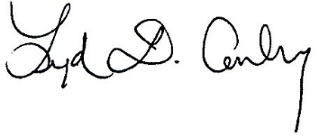
Lydia Conley
President/CEO, Association for Behavioral Health

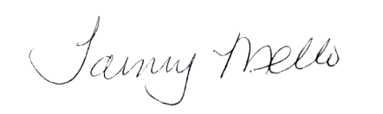

Tammy M. Mello
Executive Director, Children’s League of Massachusetts

Michael Weekes
President/CEO, Providers’ Council

In its FY2019 Annual Report, DCF reported that of the 8,809 children in out-of-home placements, 30.6% identified as Hispanic/Latinx and 14.5% identified as Black. Massachusetts Department of Children and Families Annual Report FY2019, Descriptive and Outcome Data: FY2015-FY2019, Release Date: December 30, 2019.

