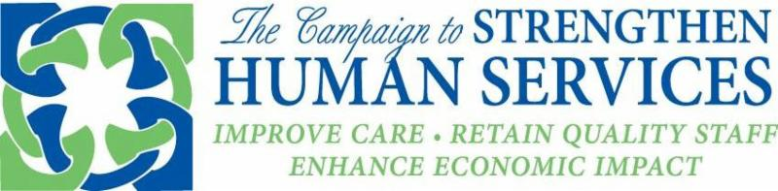

Dear Collaborative Executives:

Update on Fiscal Relief

As you know from our prior communications, EOHHS will be implementing short-term fiscal relief for Purchase of Service congregate care and certain community services. The payments will equate to 10 percent of the provider's average monthly state funding for the months of November 2019 through January 2020. Please visit EOHHS' site to read Administrative Bulletin 20-11: Add-On Rate Applicable to Certain Social Service Programs to Compensate for Costs Associated with Coronavirus (COVID-19) that facilitates implementation.

With the publication of the Administrative Bulletin, The Collaborative anticipates that state agency-specific guidance will be coming in the immediate future.

We anticipate knowing more about other forms of MassHealth relief late next week.

Governor's Order on Health Care Providers

Governor Baker issued an order on Thursday, April 2 designating Personal Care Attendants and "Direct Care staff serving social services programs" as health care providers for the purposes of the Families First Coronavirus Act to ensure that these "vital workers can continue to serve the vulnerable populations who rely on them and in turn help prevent" hospitalization or institutionalization. A copy of the order is here.

Sincerely,
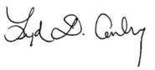
Lydia Conley
Association for Behavioral Healthcare
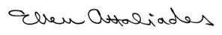
Ellen Attaliades
Association of Developmental Disabilities Providers
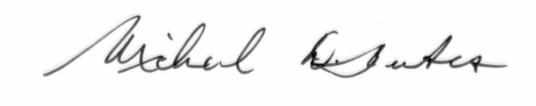
Michael Weekes
Providers' Council
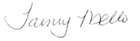
Tammy Mello
Children's League of Massachusetts

