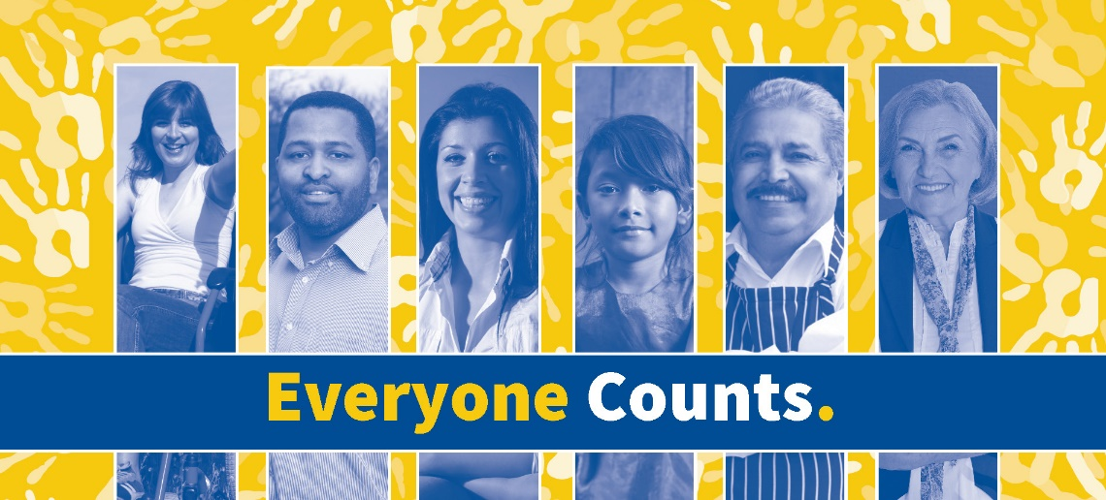
44th Annual Convention & Expo
Monday, October 7, 2019
Peer Provider Award Nomination
Please complete the below form and send to the Providers’ Council via e-mail (tempadmin@providers.org) You may contact us with questions at 617.428.3637.

The member agency I am nominating is:

That member agency’s CEO/ Executive Director is:

I am nominating them for the following reasons:

1.
2.
3.
4.
Please give us as much information as possible. Use another page if necessary.
These bullets may be used by Vanessa Welch, Peer Provider Ceremony host,
when she presents the award at the convention. We may call you for further details. Thank you!

My contact information is as follows:

Name:
Agency:
Phone:
Email:

Peer Provider Past Awardees

ABCD (2004)
Advocates (2000)
African American Federation (2000)
AIDS Project Worcester (2014)
Amego (2000)
American Training, Inc. (2016)
Amherst Survival Center (2009)
Association for Community Living (2002)
Bay Cove Human Services (2005)
Bedford Youth and Family Services (2009)
Berkshire County Arc (2007)
Beta Community Services (2005)
Boston Center for Independent Living (1999)
Boys and Girls Club Family Center (2015)
Bridgewell (2008)
Bristol Elder Services (2015)
Brockton Area Multi Services (2015)
Cambridge Family & Children's Service (2017)
Casa Esperanza (1998)
Center for Human Development (2008)
Center for Living and Working (2010)
Centro Las Americas (2005)
Children's Services of Roxbury (2018)
City Mission Society (2011)
Community Connections (2004)
Community Resources for Justice (2003)
Community Work Services (2009)
Communities for People (1999)
COMPASS (1998)
Delta Projects (2003)
Dunbar Community Center (1998)
Early Childhood Ctrs. of Gr. Springfield (2000)
Employment Options (2006)
Family Continuity (2011)
Friendship Home (2013)
Greater New Bedford Women's Center (2018)
Hattie B. Cooper Community Center (1998)
HMEA (2013)
Home for Little Wanderers (2008)
Immigrants Assistance Center (1999)
Indep. Living Ctr. of N. Shore, Cape Ann(2005)
Justice Resource Institute (2008)
Kennedy-Donovan Center, Inc. (2002)
The Key Program, Inc. (2001)
Lifelinks (2000)
Martha's Vineyard Community Services (2009)
Martin Luther King, Jr. Community Ctr. (2001)
Mass. Council on Compulsive Gambling (2010)
May Institute (2011)
Metco (2010)
MetroWest Ctr. for Independent Living (2002)
More Than Words (2012)
Morgan Memorial Goodwill Industries (2006)
Mothers for Justice and Equality (2016)
MSPCC (2011)
Multi-Cultural AIDS Coalition (MAC) (1999)
New England Center for Change (2004)
New North Citizen's Council (2010)
North Shore Arc (2004)
NuPath, Inc. (formerly CMARC Industries) (1999)
Nurtury (2014)
Old Colony YMCA (2014)
Partners for a Healthier Community (2006)
Partners for Youth with Disabilities (2007)
Pathways to Wellness (2004)
Pine Street Inn (2002)
PRIDE, Inc. (2016)
Professional Ctr. for Handicapped Children (1998)
Project COPE (2009)
Rape Crisis Center of Central MA (2003)
Rediscovery, Inc. (2006)
Riverbrook Residence (2014)
Road to Responsibility (2012)
Roca (2007)
Roxbury Multi-Service Center (2003)
Roxbury Youthworks (2007)
South Norfolk County Arc (2008)
Safe Passage (2003)
ServiceNet (2018)
Seven Hills Foundation (1998)
South End Community Center (2013)
South Middlesex Opportunity Council (2017)
Southeast Ctr. for Independent Living (1998)
Square One (2011)
Sunshine Village (2016)
Tapestry (2017)
The Care Center (2012)
UCP of MetroBoston (2004)
United Arc of Franklin County (2001)
Urban League of Springfield (2005)
Venture Community Services (2017)
Victory Human Services (2012)
Vinfen (2006)
Walker (2018)
Waltham Battered Women's Support Cmte. (2001)
Wayside Youth & Family Support Network (2004)
WCI - Work, Community, Independence (2010)
Worcester Comprehensive Child Care Svs. (2007)
WORK, Inc. (2015)
YMCA of Greater Boston (2013)
YOU Inc. (2000)

